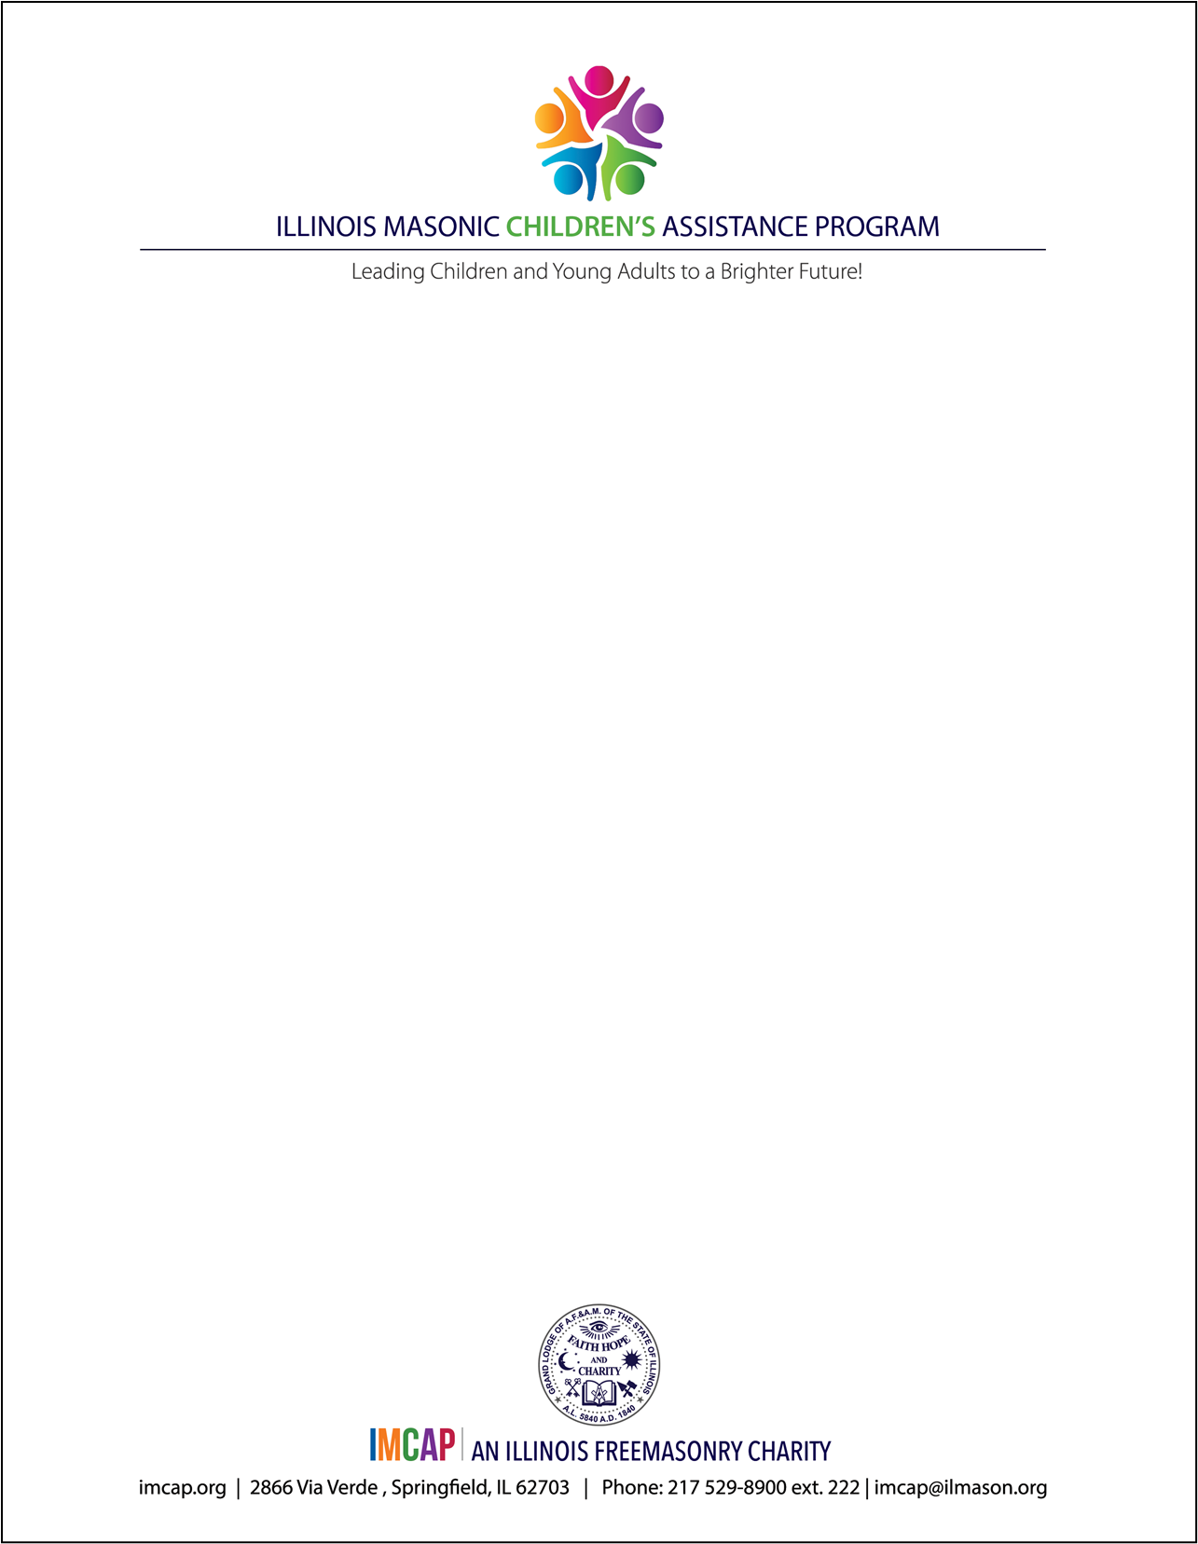

BIKES for BOOKS LODGE-BASED PROGRAM APPLICATION

**Lodge Information:**

* **Name of Lodge:**
* **Contact Person:**
* **Email:**
* **Phone:**

**Grade School Participation Information:**

* **Name of School:**
* **Address of School**
* **Contact Person:**
* **Email:**
* **Phone:**

**Complete the following questions about your Application:**

1. Number of children enrolled in the Grade School?

2. Grades participating in the Bikes for Books Reading Program?

3. Has the lodge provided monetary or volunteer assistance to the school?

Signature of Lodge Secretary: Date

Signature of Worshipful Master: Date